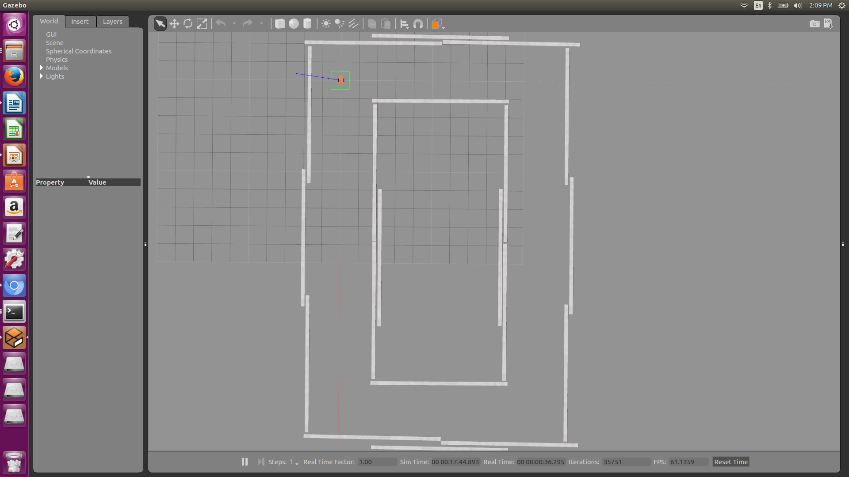

Mybot is Gazebo race track titled “race_track3.world”

In a terminal:

cd ~/mybot_test

source devel/setup.bash

roslaunch mybot_gazebo mybot_world.launch

In another terminal:

cd ~/mybot_test/src/mybot_control/scripts

python wall_follower.py